

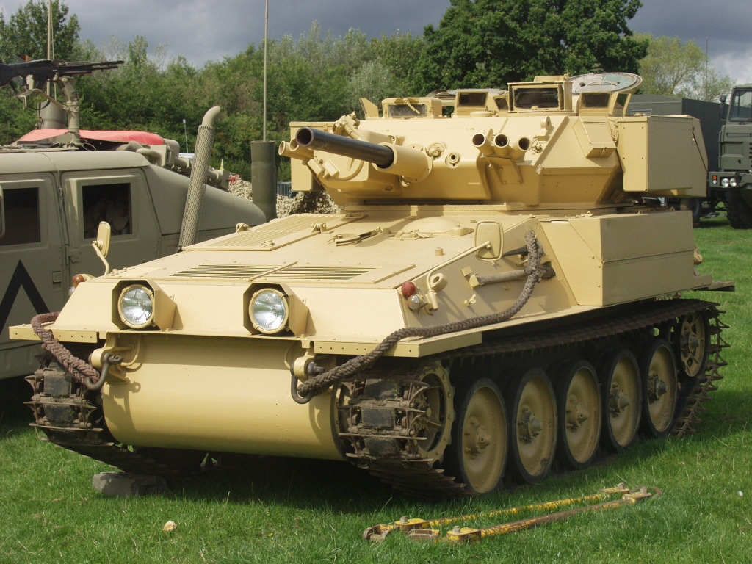

2011 Show Programme

30p

Show Organisers:

Andrew Baker – CVRT & Firepower Coordinator
Philip Palmer – Arena Coordinator
Anne Clare – Vehicle Bookings
Sally Baker – Stall’s and Promotion
Mick Browning – CVRT Guru
Scott Morris – Web Site Coordinator & Show Infrastructure

Acknowledgements:

We would like to thank all those who have given their time to help with the show and have brought their vehicles for display; we would also like to mention the following that have made this event possible:

Glenn Parry – Pyrotechnic Technician
Jim Carr – Pyrotechnic Technician
Andy (Frazzle) – Fire Safety Adviser & Infrastructure
Kelvin Findon Kent – Infrastructure
Edwin Baker – Land Owner

Welcome to the 2011 Tanks Trucks and Firepower Show. The show is co-organised by the Alvis Fighting Vehicle Trust and the Birmingham & West Midlands branch of the Military Vehicle Trust. This is the second year for our show and will provide a memorable experience for all.

Please take time to stop and have a chat with the vehicle owners who have spent many hours restoring and maintaining their vehicles, I’m sure they will be happy to answer any questions you may have.

We hope you enjoy the show and will come back next year, we aim to make this an annual event over the August Bank Holiday.

Show Number | Make - Model & Year | Reg No. & Mil Reg No. | Days Attending
101 | Landrover  101 GS |  | Sat  Sun  Mon | Y  Y  Y
102 | Leyland  Hippo | JSK 164  70 RE 85 | Sat  Sun  Mon | Y  Y  Y
103 | Dodge  WC51 | JSK 337 | Sat  Sun  Mon | Y  Y  Y
104 | AEC  Militant Mk3 Recovery  1970 | OCK 57H  87 ET 07 | Sat  Sun  Mon | Y  Y  Y
105 | Alvis  Scorpion  1971 | LNV 809L  02FD88 | Sat  Sun  Mon | Y  Y  Y
106 | Alvis  Scimitar  1984 | MBD 482K  49 AT 43 | Sat  Sun  Mon | Y  Y  Y
107 | Alvis  Scimitar  1974 | 04 FD 29 | Sat  Sun  Mon | Y  Y  Y
108 | Landrover  90 | CST 20D | Sat  Sun  Mon | Y  Y  Y
109 | Jeep  Hotchkiss | 632 XUW  632 XUW | Sat  Sun  Mon | Y  Y  Y
110 | Hotchkiss  M201 Jeep  1961 | 273 YUB | Sat  Sun  Mon | Y  Y  Y
111 | SupaCat  ATMP Mk3  2000 | TZ 47 AA  TZ 47 AA | Sat  Sun  Mon | Y  Y  Y
112 | Alvis  Scorpion  1972 |  | Sat  Sun  Mon | Y  Y  Y
113 | LandRover  Series 1 SWB  1955 |  | Sat  Sun  Mon | Y  Y  Y
114 | Alvis  Supacat M2  1989 | F57 URN | Sat  Sun  Mon | Y  Y  Y
115 | Alvis  Stormer  1972 | 03 FF 07 | Sat  Sun  Mon | Y  Y  Y
116 | Alvis  Spartan  1972 | 03 FF 07 | Sat  Sun  Mon | Y  Y  Y
117 | chevrolet. (canadian )  c15a 15 cwt gs truck.  oct 1944 | csv 331  cz6185781 | Sat  Sun  Mon | Y  Y  Y
118 | Land Rover  101 Forward Control | SWP 336P | Sat  Sun  Mon | Y  Y  Y

Show Number | Make - Model & Year | Reg No. & Mil Reg No. | Days Attending
119 | Land Rover  Defender 110 & Trailer | C139 URP  85 KE 43 | Sat  Sun  Mon | Y  Y  Y
120 | Jeep  Hotchkiss | 632 XUW | Sat  Sun  Mon | Y  Y  Y
121 | Alvis  Scorpion 76  1972 | 52 KK 25 | Sat  Sun  Mon | Y  Y  Y
122 | Alvis  Scimitar  1972 | 79 KK 29 | Sat  Sun  Mon | Y  Y  Y
123 | Alvis  Scorpion (Joe)90  1990 |  | Sat  Sun  Mon | Y  Y  Y
124 | Alvis  Stormer Command  2000 |  | Sat  Sun  Mon | Y  Y  Y
125 | Alivs  Scorpion 76  1972 | MBD 508K | Sat  Sun  Mon | Y  Y  Y
126 | Alivs  Striker  1972 | 08 FF 41 | Sat  Sun  Mon | Y  Y  Y
127 | Land Rover  Lightweight  1980 | Q842 UOC | Sat  Sun  Mon | Y  Y  Y
128 | Bedford  MJ | MYN278Y  95 KB 70 | Sat  Sun  Mon | Y  Y  Y
129 | Land Rover  Series IIA | HON 640Y  87 ER 09 | Sat  Sun  Mon | Y  Y  Y
130 | Bedford  MK | MDW 973Y | Sat  Sun  Mon | Y  Y  Y
131 | Foden  DROPS Unit | N559 HAB | Sat  Sun  Mon | Y  Y  Y
132 | land rover  lightweight ffr | b93 ufk  41 kc 34 | Sat  Sun  Mon | Y  Y  Y
133 | Chevrolet  C10 | Q190 VME | Sat  Sun  Mon | Y  Y  Y
134 | Land Rover  Series IIA 88" GS | ABW 149D | Sat  Sun  Mon | Y  Y  N
135 | Bedford  MW. R. Radio  1944 | USU 103 | Sat  Sun  Mon | N  N  Y
136 | ROFL  cvrw Fox  1978 | 00GM99 | Sat  Sun  Mon | Y  Y  Y

Show Number | Make - Model & Year | Reg No. & Mil Reg No. | Days Attending
137 | Reynolds Boughton  RB44 | J663 JFM | Sat  Sun  Mon | Y  Y  Y
138 | Alvis  Stolwart  1960 | XFF 265 | Sat  Sun  Mon | Y  Y  Y
139 | ALVIS  STRIKER  1978 | 07 FF 83 | Sat  Sun  Mon | Y  Y  Y
140 | ALVIS  STREAKER  1982 | UVP 753H  03 KJ 18 | Sat  Sun  Mon | Y  Y  Y
141 | ALVIS  SCORPION  1972 | 02 FD 37 | Sat  Sun  Mon | Y  Y  Y
142 | ALVIS  SULTAN  1978 | 01 GE 22 | Sat  Sun  Mon | Y  Y  Y
143 | ALVIS  SAMSON  1978 | 00 GM 70 | Sat  Sun  Mon | Y  Y  Y
144 | ALVIS  SABRE  1982 | 49 AT 33 | Sat  Sun  Mon | Y  Y  Y
145 | AM General  HUMVEE | A20 HMV | Sat  Sun  Mon | Y  Y  Y
146 | Alvis  Supacat  2001 | TZ 48AA | Sat  Sun  Mon | Y  Y  Y
147 | Alvis  Supacat  2001 | KT51 DGV  TZ 50 AA | Sat  Sun  Mon | Y  Y  Y
148 | Alvis  Supacat  2002 | X197 RNV  TZ 50 AA | Sat  Sun  Mon | Y  Y  Y
149 | Landrover  Defender 90 | CST 20D | Sat  Sun  Mon | Y  Y  Y
150 | Alvis  Sabre  1974 | 04 FD 58 | Sat  Sun  Mon | Y  Y  Y
151 | Alvis  Samaritan  1972 | LNV 865L  00 GH 59 | Sat  Sun  Mon | Y  Y  Y
152 | Scammell  Explorer  1951 | YSY250 | Sat  Sun  Mon | Y  Y  Y
153 | GKN  Simba  1985 | F447 GNT | Sat  Sun  Mon | Y  Y  Y
154 | Alvis  Sabre  1973 | ANW 587M  04 FD 34 | Sat  Sun  Mon | Y  Y  Y
155 | Alvis  Striker  1978 | n/a  07 FF 87 | Sat  Sun  Mon | Y  Y  Y

Show Number | Make - Model & Year | Reg No. & Mil Reg No. | Days Attending
156 | Alvis  Samson  1973 | n/a  00 GM 70 | Sat  Sun  Mon | Y  Y  Y
157 | Alvis  Spartan  1982 | n/a  48 AT 85 | Sat  Sun  Mon | Y  Y  Y
158 | Leyland  Martian FV 1121 | PLJ 251W  43 BM 65 | Sat  Sun  Mon | Y  Y  Y
159 | Land Rover  Defender 90 FFR Hard top Winterised & Waterproofed  1991 | H613POJ  61KJ21 | Sat  Sun  Mon | Y  Y  Y
160 | Land Rover  110 2.5D FFR hard top  1985 | D496UBM  61KJ21 | Sat  Sun  Mon | Y  Y  Y
161 | WARD LA FRANCE + JEEP GPW  M1A1  1944 1945 | BSL432 | Sat  Sun  Mon | Y  Y  Y
162 | AEC  Militant MKI |  | Sat  Sun  Mon | N  N  N
163 | AEC  Militant MK I | XFO 274 | Sat  Sun  Mon | Y  Y  Y
164 | HJarley Davidson  WLA | CAS 668 | Sat  Sun  Mon | Y  Y  Y
165 | Land Rover  Series 111 109" | A781 MWD  64 KC 69 | Sat  Sun  Mon | Y  Y  Y
166 | Land Rover  Lightweight E.S. SFR3 | LBH 774 Y | Sat  Sun  Mon | Y  Y  Y
167 | Rolls Royce  V12 Meteor - Merlin Engine |  | Sat  Sun  Mon | Y  Y  Y
168 | Alvis  Tactica  1998 | HI 90 AA | Sat  Sun  Mon | N  Y  Y
169 | Ford. Austin. Chevrolet  GPW. K9. C15  1945. 1954. 1942 | RSU939. LSU834. 106XUF | Sat  Sun  Mon | Y  Y  Y
170 | Willys  MB Jeep  8 January 1944 (Saturday) | 703 YUE | Sat  Sun  Mon | Y  Y  Y
171 | Land Rover  101 | XEC 99Y  00 AM 78 | Sat  Sun  Mon | Y  N  N
172 | Dodge  M37 | 998 UXB | Sat  Sun  Mon | Y  Y  Y
173 | Harley Davidson  MT350 | L276 YVU  23 LL 93 | Sat  Sun  Mon | Y  Y  Y

Show Number | Make - Model & Year | Reg No. & Mil Reg No. | Days Attending
174 | Honda  XR 250 R | P321 HBC  JW 03 AA | Sat  Sun  Mon | Y  Y  Y
175 | Dodge  WC54 Ambulance  1944 | 945 XUL | Sat  Sun  Mon | Y  Y  Y
176 | Willys  MB Jeep | 6624 AH | Sat  Sun  Mon | N  Y  N
177 | Rolls-Royce  V12 Meteor-Merlin Engine |  | Sat  Sun  Mon | Y  Y  Y
178 | Royal Enfield  1942 WDCOB  1942 | GJH 891 | Sat  Sun  Mon | Y  Y  N
179 | AEC  MK1 Millitant LWB | CSL 917 | Sat  Sun  Mon | Y  Y  N
180 | landrover 109  Carawagon  1966 | MPL 263D | Sat  Sun  Mon | Y  Y  Y
181 | Lynx  MK9A |  | Sat  Sun  Mon | Y  Y  Y
182 | SAS Land Rover Pinkie  Defender |  | Sat  Sun  Mon | Y  Y  Y
183 | HUMVEE  M996 TOW USMC |  | Sat  Sun  Mon | Y  Y  Y
184 | Austin  Champ  1954 | KNX 439D  51BE60 | Sat  Sun  Mon | Y  Y  N
185 | Ford  GPW | FOR 712 | Sat  Sun  Mon | N  Y  N
186 | ZIL 131  ZIL 131  1975 | Q697 VBD | Sat  Sun  Mon | Y  Y  Y
187 | Land Rover  Rover 8 | TFO 602 | Sat  Sun  Mon | N  N  Y
188 | Land Rover  Series II lightweight | TRE 336 R | Sat  Sun  Mon | Y  Y  Y
189 | FORD  GPW  1942 | SOR842 | Sat  Sun  Mon | Y  Y  N
190 | LandRover  Defender | K867 OYS | Sat  Sun  Mon | Y  Y  Y
191 | Chevrolet  M1008  1986 | B95 FNO | Sat  Sun  Mon | Y  Y  N
192 | Scammell  Explorer  1953 | WSL773 | Sat  Sun  Mon | Y  Y  N

Show Number | Make - Model & Year | Reg No. & Mil Reg No. | Days Attending
193 | Willys  MB | OAS 381 | Sat  Sun  Mon | Y  Y  Y
194 | Land Rover  Lightweight Series iii |  | Sat  Sun  Mon | N  N  N
198 | Land Rover  Derender | L 124 NAW | Sat  Sun  Mon | Y  Y  Y
199 | ford  gpw  1942 | 361xup  us navy | Sat  Sun  Mon | Y  Y  N
200 | Austin  K5  1943 | PPM 319  L5192186 | Sat  Sun  Mon | Y  Y  Y
201 | Bedford  M1120 4x4 | UNP 350V | Sat  Sun  Mon | Y  Y  N
202 | Triumph  Dolomite Sprint  1979 | HHP 591V | Sat  Sun  Mon | Y  Y  N
203 | Daimler  Ferret 2/3  1960 | BSL 434  00DA58 | Sat  Sun  Mon | Y  Y  Y
204 | VICKERS  ABBOT S.P.G.  1966 | TRX 159 D  07 EB 38 | Sat  Sun  Mon | Y  Y  Y
205 | Land Rover  1/2 Ton GS ex RAF  1980 | Q81 NYB | Sat  Sun  Mon | Y  Y  N
206 | land rover  110  1965 | dun 841c | Sat  Sun  Mon | Y  Y  Y
207 | Albion CX22S  Gun Tractor  1944 | SVS-988  H5191703 | Sat  Sun  Mon | Y  Y  Y
208 | Land Rover  80" Series 1 | 368 RAF  43 AA 83 | Sat  Sun  Mon | Y  N  N
209 | Bedford  MJ  1984 | B215 KNV  95KB28 | Sat  Sun  Mon | Y  Y  Y
210 | Bedford  TM  1980 | BWT 329X | Sat  Sun  Mon | Y  Y  Y
211 | Scammell  Explorer | JSU 265 | Sat  Sun  Mon | Y  Y  Y
212 | GKN Saxon  105 Battalion Command Vehicles 1987 | E237 RRP  98KF12 | Sat  Sun  Mon | Y  Y  N
213 | Willys  MB  1944 | USV 972 | Sat  Sun  Mon | Y  Y  Y
214 | GMC  CCKW353  1943 |  | Sat  Sun  Mon | Y  Y  Y

Show Number | Make - Model & Year | Reg No. & Mil Reg No. | Days Attending
215 | Willys  MB Jeep  1944 | FPG 912 | Sat  Sun  Mon | Y  Y  Y
216 | Willys Jeep  M38A1 | SSL 789 | Sat  Sun  Mon | Y  Y  Y
217 | Mercedes Benz  280 GE BRIXMIS  1985 | 12  10 XK 81 | Sat  Sun  Mon | Y  Y  Y
218 | dodge  wc63 6x6  1943 | lvs779 | Sat  Sun  Mon | Y  Y  Y
219 | LAND ROVER  SERIES 2  1959 | 3602EV | Sat  Sun  Mon | Y  Y  Y
220 | Willys  M38A1 Jeep  1953 | 657 XUE | Sat  Sun  Mon | Y  Y  Y
221 | REO  M35 Truck  1958 | LAS 225 | Sat  Sun  Mon | Y  Y  Y
222 | Landrover  EX MOD 110 Defender  1986 | C673 TMO | Sat  Sun  Mon | Y  Y  N
223 | Bombardier  Motorcycle, SAS, 250cc Can-Am  1978 | N/A  23HG80 | Sat  Sun  Mon | Y  Y  Y
224 | Land Rover  series III  1959 | 3602 ev | Sat  Sun  Mon | Y  Y  Y
225 | Willys MB  Jeep  1942 | 7789 NW | Sat  Sun  Mon | N  Y  N
226 | Volvo C303  TGB 11a  1977 | ADD 537 S | Sat  Sun  Mon | Y  Y  N
227 | Land Rover  Series III  1980 | KAW 98 V  17 GX 13 | Sat  Sun  Mon | Y  Y  Y
228 | Daimler  Ferret  1963 | BOC 892 A | Sat  Sun  Mon | N  Y  N
229 | Harley Davidson WLC  45 Model  1943 | TAS 882  N/A | Sat  Sun  Mon | Y  Y  Y
230 | Jeep. (Plus French Diorama)  M201  1959 | WSL 561  N/a | Sat  Sun  Mon | Y  Y  Y
231 | GAZ  Gaz 69E Orel-1 | DDJ 970J | Sat  Sun  Mon | Y  Y  Y

Arena Timetable

11:00 – 11:30 | Post War Vehicle Display
11:30 – 12:00 | CVRT Driving Display
12:00 – 12:30 | CVRT Firepower Display * **
12:30 – 13:00 | Softskin Vehicle Display
13:00 – 13:30 | War Time Vehicle Display
13:30 – 14:00 | Military Landrover Display
14:00 – 14:30 | Vehicle Recovery Display
14:30 – 15:00 | Vehicle Recovery Display
15:00 – 15:30 | CVRT Driving & Firepower **
15:30 – 16:00 | Falklands Vehicle Display
16:00 – 16:30 | Gulf War Vehicle Display
16:30 : 17:00 | Car Crushing!!

* This Display will take place @ 11:45 on Saturday

** This Display involves pyrotechnics and loud noises that may frighten pets and young children

